Code Output

Initial Screen
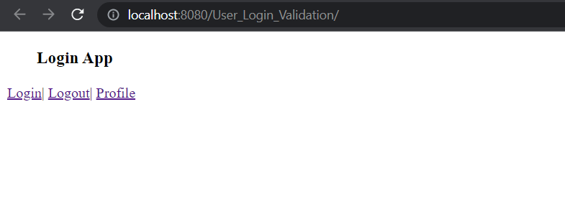

Login Screen
Name: Abdullah
Password: abdullah123
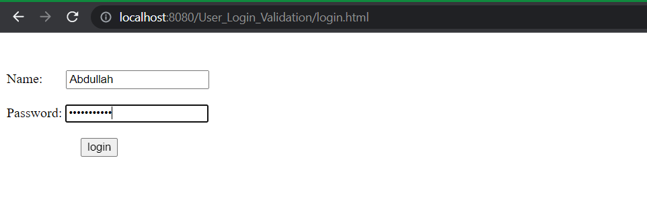

Post Successful Login
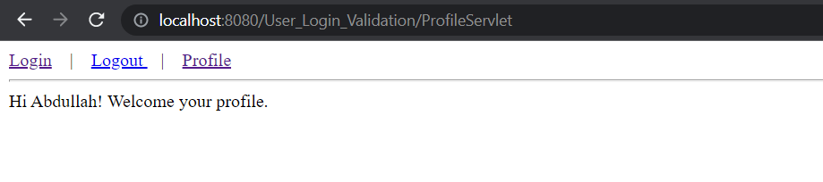

Profile Page

Post Logout Page
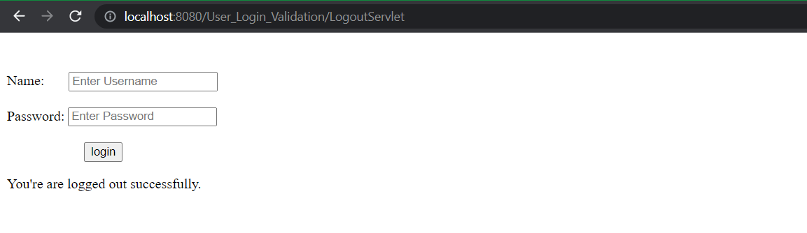

Login Page after entering incorrect login credentials
